PROPERTY ANALYSIS -DOCUMENTATION

**Initial Data Loading with SSIS**

1. AUS_SubCityDistrictState_Data data set is loaded to load_Aus_SubCityDistrictState.

*AUS_SubCityDistrictState_Data Table design.*

The sequence container Australia Location deals with loading this table.

Truncate the load_ table before loading to avoid data duplication. – Execute SQL task is used.

ETL Load Geography control flow deals with loading the excel file.

OLE DB Destination is load_Aus_SubCityDistrictState table

1. *NSW_PropertyMedainValue* is loaded into table load_NSW_PropertyMedianValue

Table Design

The sequence container NSW Property value deals with loading this table.

Truncate the load_ table before loading to avoid data duplication. – Execute SQL task is used.

ETL Load NSW Property Median Value control flow deals with loading the excel file to destination Load_NSW Property Median Value table.

1. NSW-Public-Schools-Master-Dataset-07032017 .csv file is loaded to load_ Load_Nsw_Public_Schools_Master_Dataset table

Table design

The sequence container NSW Public Schools deals with loading this table.

Truncate the load_ table before loading to avoid data duplication. – Execute SQL task is used.

ETL Load NSW PublicSchoolMasterDataset control flow deals with loading the excel file to destination Load_Nsw_Public_Schools_Master_Dataset.

Some value in town_suburb column has data with trailing spaces. Derived column is used to remove those spaces.

Data conversion is used to convert the non-Unicode string type to Unicode string type.

.

**Dimensional Modeling**

Bus matrix

Snowflake schema is designed.

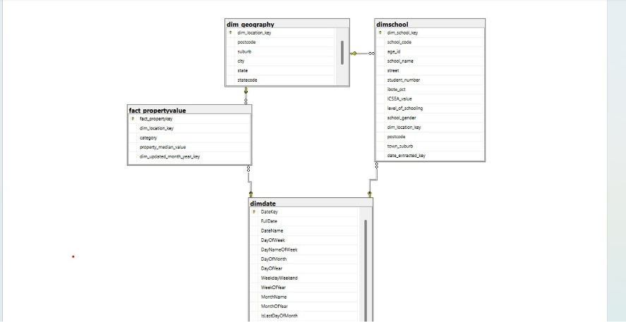

Dimension Tables - dim_geography,dimdate,dimschool

Fact Table - fact_propertyvalue

**Data Transformation Pipeline.**

Second SSIS package is created to load data to dim and fact tables.

Table Design:

dim_geography

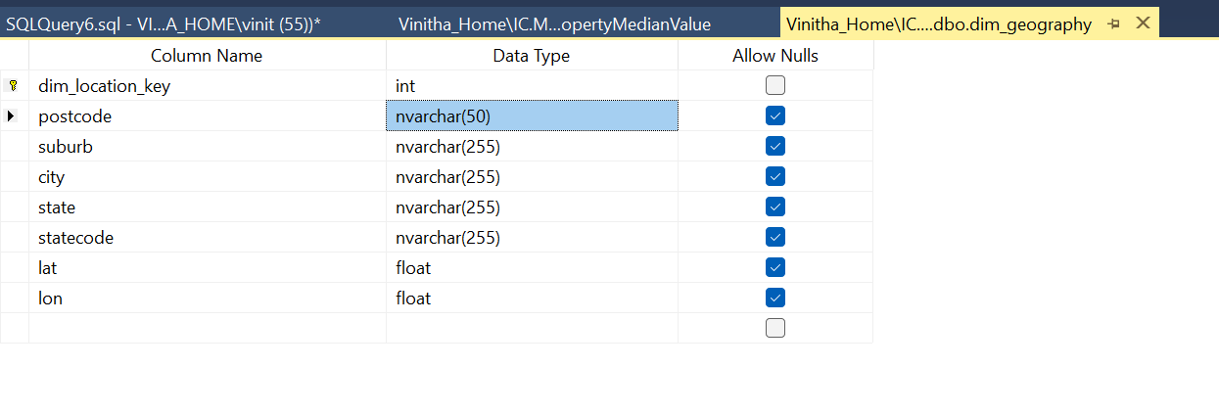

Identity specification is set to yes for surrogate key.

Dimdate:

dimschool

For surrogate key identity specification is set to yes.

Also dim_location_key is created that refers to Dim_geography table.

And data_extracted_key is created that refers to Dim_date table.

Data Flows:

*Geography Dimension* – To load date from [load_Aus_SubCityDistrictState] to dim_geography table.

Slowly changing Dimension Type 1 used.

*School Dimension – To load data from Load_Nsw_Public_Schools_Master_Dataset to DimSchool table.*

All the values are fetched from staging table.

Use derived column to change the format and type of date_extracted column.

Next Data Conversion is used to convert the data type of age_id from string to int data type.

Lookup location key step is to map suburb from school data set to dim_geography dataset and setup location key in dim_school table.

Lookup data extracted key step is to map the data extracted from public school data set to dimdate table and setup dimdate key in dimschool table.

Next Slowing changing Dimension Type 1 is used.

*Property Fact Table -To load data to fact table.*

Derived column Data Transformation in state and city is used to

* 1. Create new column category in fact table.
  2. To clean data in state column. REPLACE(state,"NEW SOUTH WALES_NSW","New South Wales").

Some rows has state values as NEW SOUTH WALES_NSW which is same as New South Wales.

DimLocationKeyLookup -Is used to map suburb and postcode to DimGeography table and get Dimlocation key .

Data conversion is used to change the datatype of updated_year and updated_month similar to the datatype in dimdate table.

Lookup in Dimdate for updated month and year is used to map to dimdate table and to fetch the date key.

Finaly all the rows are loaded to fact table.